LT-01, Rev.0, 01.09.2023

 | KONGU ENGINEERING COLLEGE  (Autonomous) PERUNDURAI – 638060  INTERNAL QUALITY ASSURANCE CELL | 
 | Laboratory Manual


Department of Computer Science and Engineering 22CSL62-Machine Learning Laboratory (2022R)

Prepared By
Dr.P.Yuvarani.
Ms.P.Santhiya,
Ms.P.Kalaivani, Ms.K.Suvalakshmi,

Approved By

Dr.S. Malliga Head of the Department

Department of Computer Science & Engineering

22CSL62-Machine Learning Laboratory Record

Name Programme

Branch Section Semester Roll No

Certify that this is bonafide record of work done by the above student of

the 22CSL62-Machine Learning Laboratory Record during the year 2024 - 2025.

Submitted for the Examination held on

Signature of the

Lab Incharge Head of the Department

Examiner 1 Examiner 2
INDEX

EX.NO | Name of Experiment | Conduct of Experiment(30) | Record  Observation (20) | Viva (10) | Total (60) | Signature
1. | Introduction to Machine Learning Tools
2. | Exploration of UCI repository datasets. and tools like WEKA, Rapid Miner, Python sci-  kit-learn, etc.
3. | Perform data manipulation using NumPy and Pandas and, data visualization using matplotlib.
4. | Implement Naïve Bayes classification and predict the class label for a given data
5. | Implement linear models to approximate the  given data
6. | Implement a multi-layer perceptron algorithm for the specified data.
7. | Implement K-NN algorithm for the specified  data.
8. | Implement SVM algorithm for the given data.
9. | Implement the concept of decision tree with the suitable dataset.
10. | Implement K-means clustering algorithm for the given data and visualize and interpret the result.
11. | Implement genetic operators and Q-learning for the given data.
12. | Build a supervised model / unsupervised  model using appropriate dataset in the cloud framework
13. | Mini Project

EX. No : 01 STUDY OF WEKA, RAPID MINER TOOLS AND UCI REPOSITORY DATASETS

AIM:
To explore the various features of Weka, Rapid miner Tools and UCI Repository
datasets.

PROCEDURE:
FUNDAMENTAL TERMS:
Feature/Attribute: A single column of data is called a feature. It is a component of an observation and is also called an attribute of a data instance. Some features may be inputs to a model (the predictors) and others may be outputs or the features to be predicted.
Attribute values: Attribute values are numbers or symbols assigned to an attribute.
Target attribute: Target attribute is a special attribute which corresponds to the label of each instance.
Instance: Each row in the dataset is called the instance.
Datasets: A collection of instances is a dataset.
Training Dataset: A dataset that is fed into the machine learning algorithm to train the model.
Testing Dataset: A dataset that is used to validate the accuracy of the model but is not used to train the model.

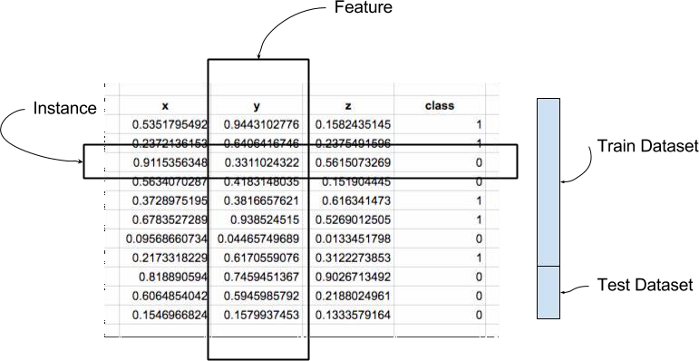
WEKA:
- Download and install weka,
- In the window, select the explorer button from the available five buttons.
- The weka supports two common formats for files: ARFF-Attribute Relation File Format
CSV-Comma Separated Values
EXPLORER:
The explorer window contains preprocess, classify, cluster, associate, select attribute and visualize from which select preprocess.
OPEN FILE:
To open the default dataset into the machine.
OPEN URL:
To access the dataset in the website.
OPENDB:
To open the database which the user saved in the machine.
CHOOSE:
To select the filter option.
EDIT:
To set the filled dataset before and after the filter.
FILTERS:
To filter or tune the data.
- REMOVE(ATTRIBUTE) :

A filter that removes a range of attributes from the dataset.
  - Open file button is clicked
  - Choose weka and open the data folder
  - Choose weather numeric.arff
  - In filter tab, click choose button
  - Choose unsupervised and select attribute
  - Select remove filter
  - Specify the attribute index in the filter editor window
  - Apply button is clicked
  - Choose the edit button to see the output data after filtering the attribute
- REMOVE WITH VALUES:
Filters instances according to the value of the attribute.
  - Open file button is clicked
  - Choose weather numeric.arff
  - Choose unsupervised and select instance
  - Select “remove with values” filter
  - Set attribute index to 2 and split point to 60
  - The output contains column dataset in which the second column contains only the values which is above the split point

- REPLACE WITH MISSING VALUES:
Replace all missing values for nominal and numeric attributes in a dataset with the modes and means from the training data.
  - Choose unsupervised and select attributes.
  - Select “remove missing values” filter.
  - Click “edit” and delete any one of the data.
  - After applying the filter, the deleted values or any missing values are replaced by taking the mean values.

- REMOVE PERCENTAGE:
A filter that removes a given percentage of a database.
  - Choose unsupervised and select instance.
  - Select “remove percentage” filter.
  - Set percentage as “50.0”
  - After filter is applied , from the dataset 50% of the instance are removed

- REMOVE FREQUENT VALUES:
Determine which values of attribute or retained and filters the instances accordingly.
  - Choose unsupervised and select instances.
  - Select “remove frequent values” filter.
  - Specify the attribute index as 2.
  - When apply is clicked the less frequently repeated values are removed
OUTPUT:
Dataset: Weather.numeric.arff
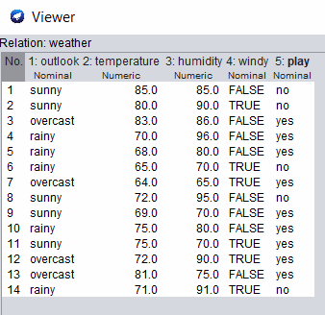
Applying Remove Filter:
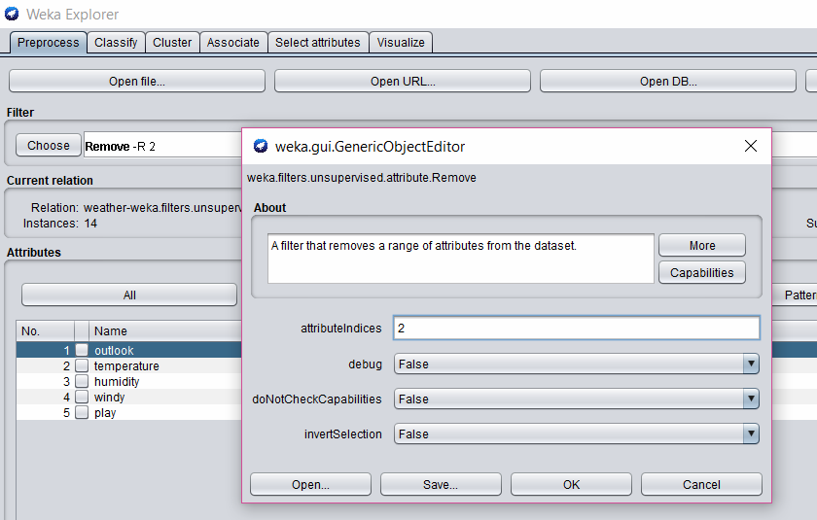
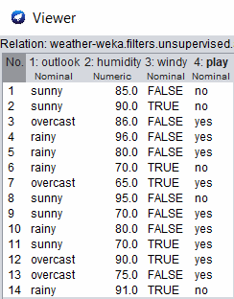

Applying Remove with values Filter
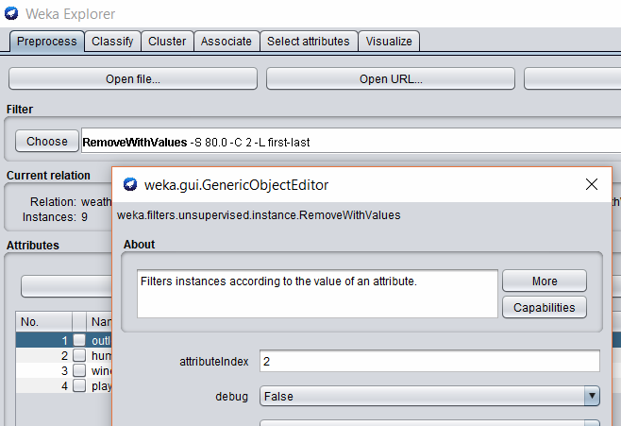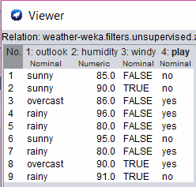
Applying Replacing Missing Value Filter
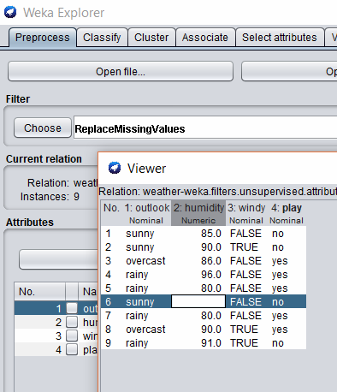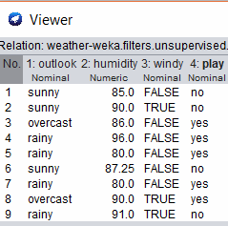

Applying Remove Percentage Filter
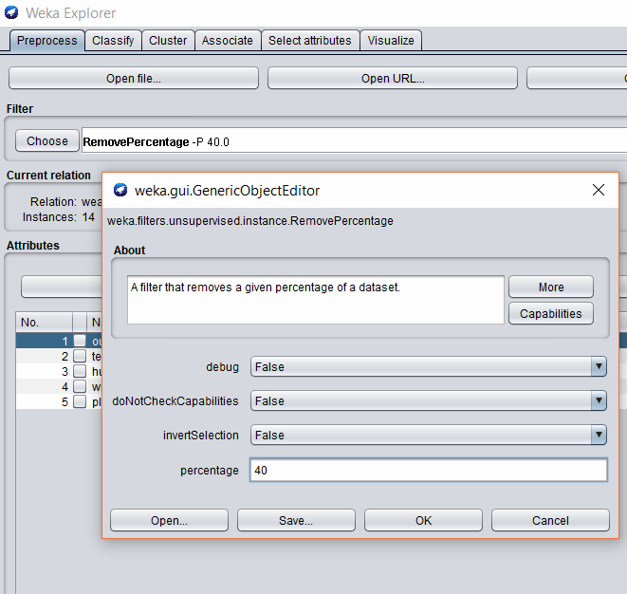

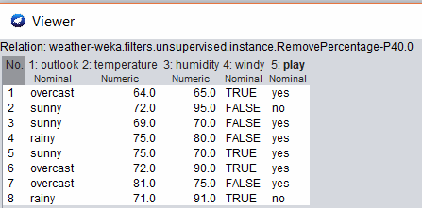

Applying Remove Frequent Values Filter
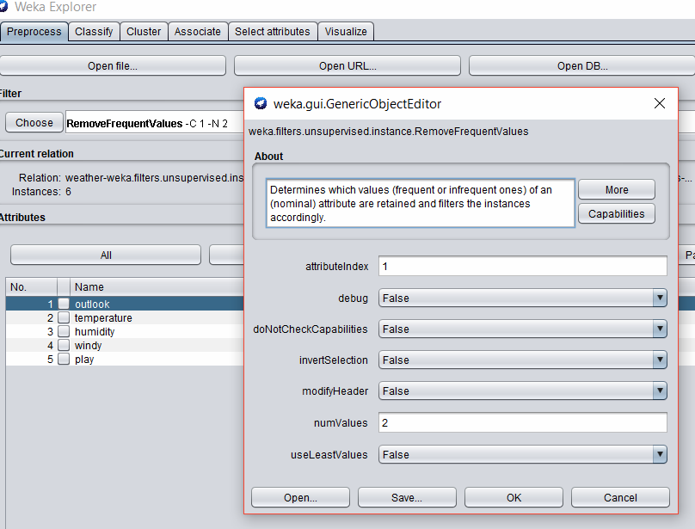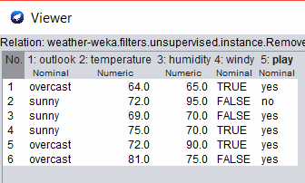

RAPIDMINER:

Design View
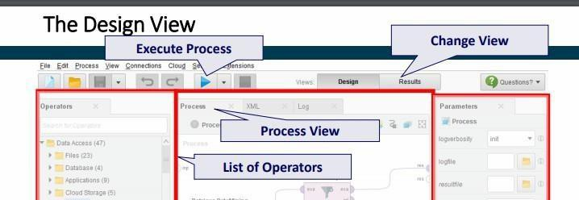
Preprocessing: Replace missing values

- Load the Labor-Negotiations data set from the Samples folder.
- Drag and drop the Replace Missing Values Operator. It applies the replacement on all attributes in the dataset which have at least one missing value.
- Click the play button and view the output.
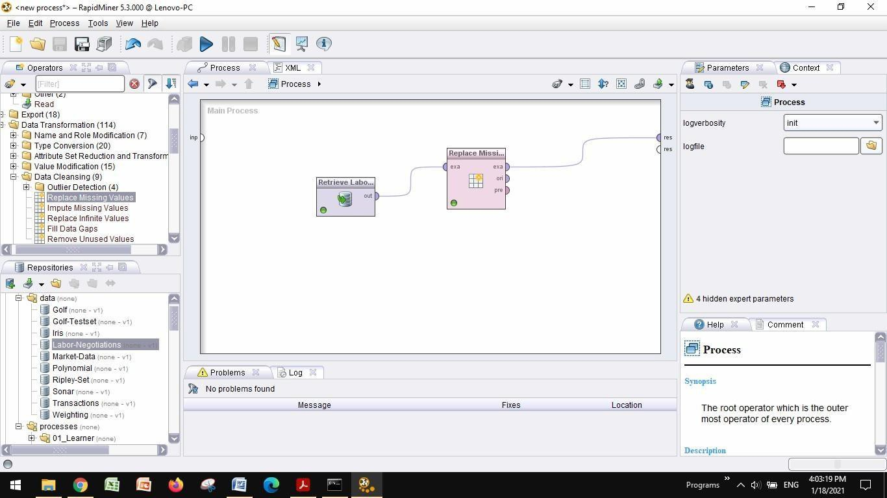

Dataset with missing values:
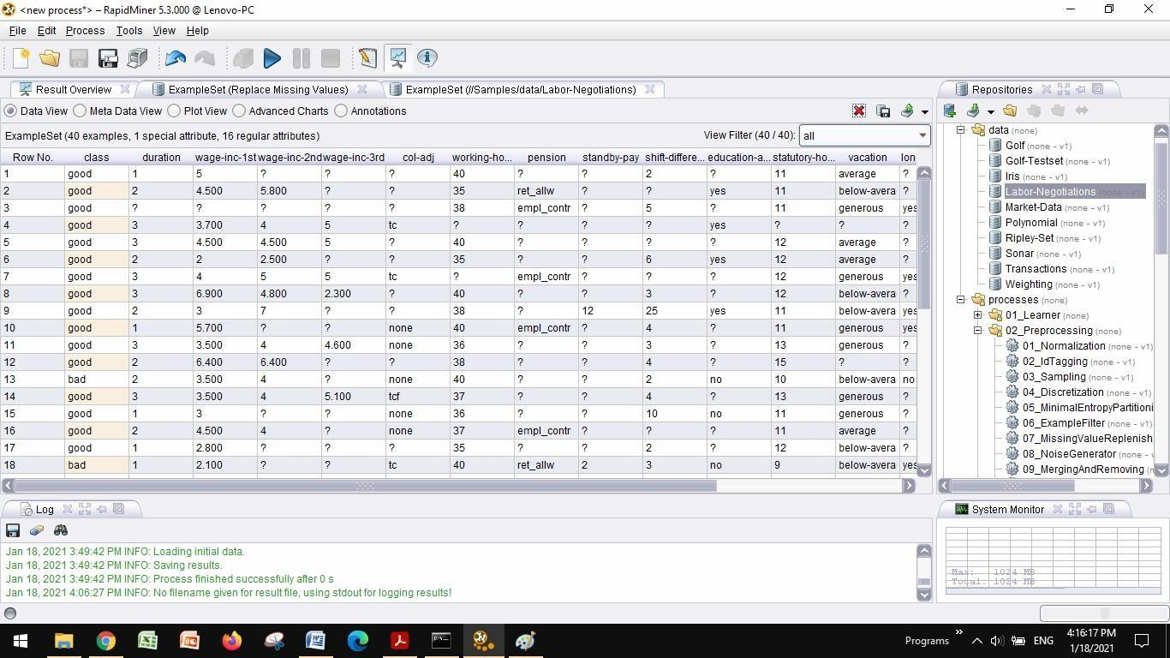

Dataset after filling missing values:
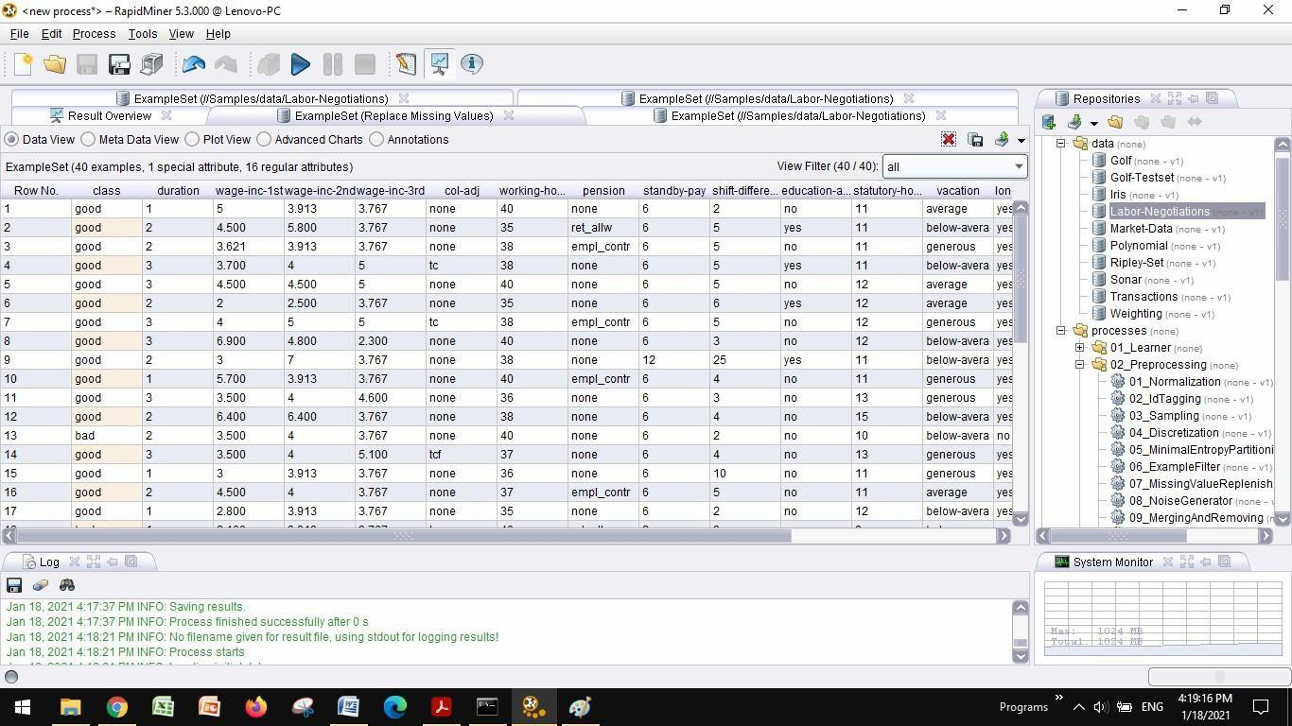

UCI Repository:
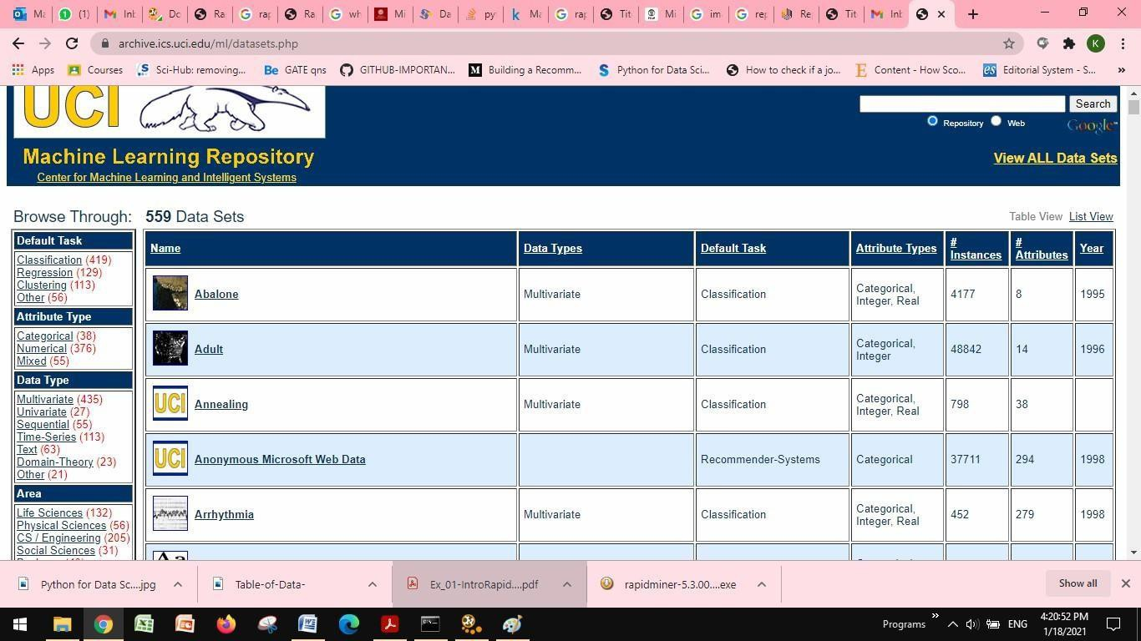

Sample dataset:
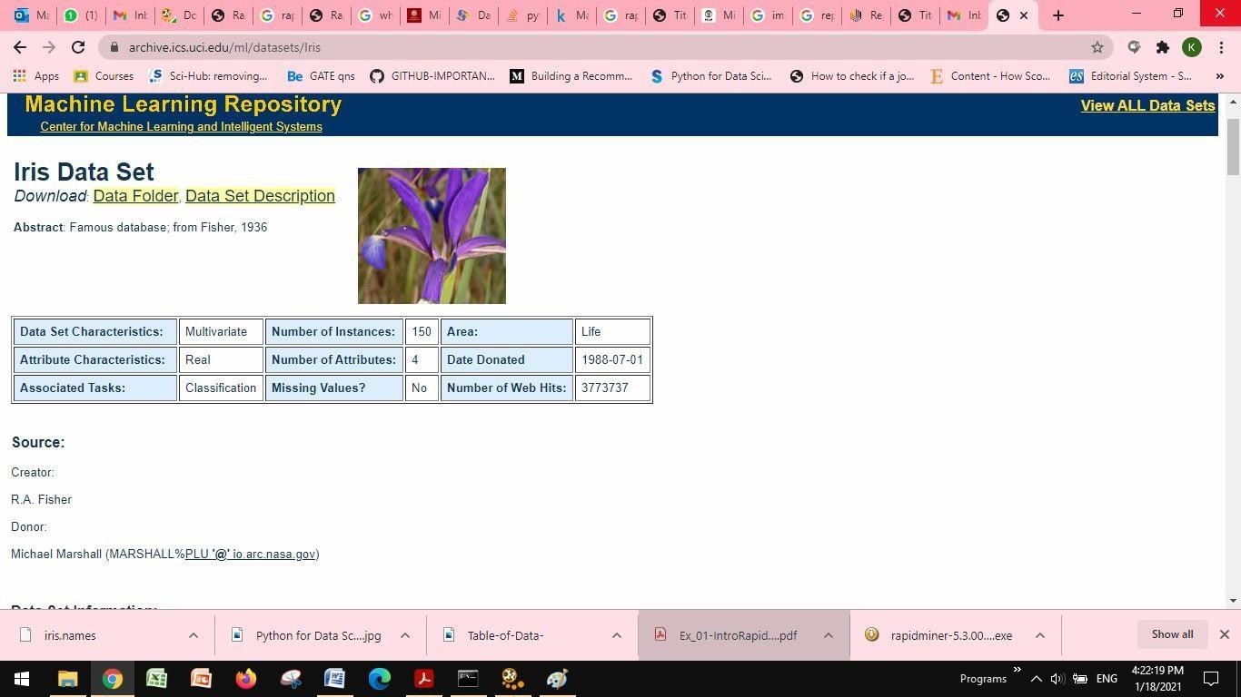

Conclusion: The various features of Weka Tool, Rapidminer Tool and UCI Repository datasets have been explored.

Ex.No.2:

AIM:
To perform data manipulation using numpy and pandas and data visualization using matplotlib.

Program:
  - Data Manipulation using Numpy

NumPy stands for Numerical Python. NumPy is a python library used for working with arrays.

array(): Used to create numpy ndarray
copy(): It is a new array and it owns the data and any changes made to the copy will not affect original array
view():View is just a view of the original array.The view does not own the data and any changes made to the view will affect the original array
reshape() : Used to change the dimensions of the array concatenate(): Used to join two or more arrays into single array
split(): Splitting is reverse operation of Joining. Array and number of splits are passed as argument.
where(): search an array for a certain value, and return the indexes that get a match sort(): Sorting means putting elements in an ordered sequence.
random: Module to work with random numbers

Program to create array:

Output:

Program to demonstrate copy:

Output:

Program to demonstrate view:

Output:

Program to demonstrate reshape:

Output:

Program to demonstrate split:

Output:

Program to demonstrate where:

Output:

Program to demonstrate sort:

Output:

Program to demonstrate random:

Output:

Data Manipulation using Pandas

Pandas is a python library that allow us to analyze big data and make conclusions based on statistical theories.
read_csv(dataset name): Used to load dataset
dropna(): Used to remove rows or columns with missing values fillna(): Used to replace the NaN values with other values mean(): Used to find the mean of the values for the requested axis
sum(): Function return the sum of the values for the requested axis
count(): is used to count the no. of non-NA/null observations across the given axis.

Program for handling missing data:
import numpy as np import pandas as pd

# Load Dataset

# Dropping missing data

# Filling missing data

Output:

- Program for aggregation in panda:
import numpy as np import pandas as pd

# Mean

# Count

# Sum

Output:

Data Visualization using Matplotlib

Matplotlib is a multi-platform data visualization library built on NumPy arrays. Matplotlib consists of several plots like line, bar, scatter, histogram etc.
figure(): Thought of as a single container that contains all the objects representing axes, graphics, text, and labels
axes(): Bounding box with ticks and labels, which will eventually contain the plot elements that make up our visualization.
xlim(), ylim(): Used to set x and y limit for axis axis[xmin,xmax,ymin,ymax]: Used to set x and y limit for axis xlabel(), ylabel(): Used to set label for axis
legend(): Used to set label for multiple plot lines in graph plt.axis(‘equal’): Equal splitting of x and y limit values plt.axis(‘tight’): Default spacing left between values of x and y limits plt.savefig(): Used to save the output graph to specified format

Line Drawing

Program:

Output:

Scatter Plot

Program:

Output:

Bar chart

Program:

Output:

+

Result:
Data manipulation using numpy , pandas and data visualization using matplotlib are successfully performed.

Ex.No:3
Write a python program to implement Naive Bayes Classification and predict the class label for the given data.
Aim:
To write a python program to implement Naive Bayes Classification and predict the class label for the given dataset.

Naive Bayes Classification:

Naive Bayes is a statistical classification technique based on Bayes Theorem. It is one of the simplest supervised learning algorithms. Naive Bayes classifier is the fast, accurate and reliable algorithm. Naive Bayes classifiers have high accuracy and speed on large datasets.

Naive Bayes classifier assumes that the effect of a particular feature in a class is independent of other features. For example, a loan applicant is desirable or not depending on his/her income, previous loan and transaction history, age, and location. Even if these features are interdependent, these features are still considered independently. This assumption simplifies computation, and that's why it is considered as naive. This assumption is called class conditional independence.
P(D/h) = 𝑃(ℎ/𝐷)𝑃(𝐷)/𝑃(ℎ)

- P(h): the probability of hypothesis h being true (regardless of the data). This is known as the prior probability of h.

- P(D): the probability of the data (regardless of the hypothesis). This is known as the prior probability.

- P(h|D): the probability of hypothesis h given the data D. This is known as posterior probability.

- P(D|h): the probability of data d given that the hypothesis h was true. This is known as posterior probability.

Procedure:

- Step 1: Calculate the prior probability for given class labels

- Step 2: Calculate conditional probability with each attribute for each class

- Step 3: Multiply same class conditional probability

- Step 4: Multiply prior probability with step 3 probability

- Step 5: See which class has a higher probability, given the input belongs to the higher probability class.

Sample Dataset

Weather | Temperature | Play
Sunny | Hot | No
Sunny | Hot | No
Overcast | Hot | Yes
Rainy | Mild | Yes
Rainy | Cool | Yes
Rainy | Cool | No
Overcast | Cool | Yes
Sunny | Mild | No
Sunny | Cool | Yes
Rainy | Mild | Yes
Sunny | Mild | Yes
Overcast | Mild | Yes
Overcast | Hot | Yes
Rainy | Mild | No

To calculate the probability of playing when the weather is overcast, and the temperature is mild.

Probability of playing:
P(Play= Yes | Weather=Overcast, Temp=Mild) = P(Weather=Overcast, Temp=Mild | Play= Yes)P(Play=Yes) (1)
P(Weather=Overcast, Temp=Mild | Play= Yes)= P(Overcast |Yes) P(Mild |Yes) (2)
- Calculate Prior Probabilities: P(Yes)= 9/14 = 0.64
- Calculate Posterior Probabilities: P(Overcast |Yes) = 4/9 = 0.44 P(Mild |Yes) = 4/9 = 0.44
- Put Posterior probabilities in equation (2) P(Weather=Overcast, Temp=Mild | Play= Yes) =
0.44 * 0.44 = 0.1936(Higher)
- Put Prior and Posterior probabilities in equation (1) P(Play= Yes | Weather=Overcast, Temp=Mild) = 0.1936*0.64 = 0.124
Similarly, you can calculate the probability of not playing:
Probability of not playing:
P(Play= No | Weather=Overcast, Temp=Mild) = P(Weather=Overcast, Temp=Mild | Play= No)P(Play=No) (3)
P(Weather=Overcast, Temp=Mild | Play= No)= P(Weather=Overcast |Play=No) P(Temp=Mild | Play=No) (4)
- Calculate Prior Probabilities: P(No)= 5/14 = 0.36
- Calculate Posterior Probabilities: P(Weather=Overcast |Play=No) = 0/9 = 0 P(Temp=Mild | Play=No)=2/5=0.4
- Put posterior probabilities in equation (4) P(Weather=Overcast, Temp=Mild | Play= No) = 0 * 0.4= 0
- Put prior and posterior probabilities in equation (3) P(Play= No | Weather=Overcast, Temp=Mild) = 0*0.36=0
The probability of a 'Yes' class is higher. So you can say here that if the weather is overcast than players will play the sport.

Sample Implementation:
weather=['Sunny','Sunny','Overcast','Rainy','Rainy','Rainy','Overcast','Sunny','Sunny', 'Rainy','Sunny','Overcast','Overcast','Rainy'] temp=['Hot','Hot','Hot','Mild','Cool','Cool','Cool','Mild','Cool','Mild','Mild','Mild','Hot','Mild']

play=['No','No','Yes','Yes','Yes','No','Yes','No','Yes','Yes','Yes','Yes','Yes','No'] # Import LabelEncoder
from sklearn import preprocessing #creating labelEncoder
le = preprocessing.LabelEncoder()
# Converting string labels into numbers. weather_encoded=le.fit_transform(weather) print (weather_encoded)
# Converting string labels into numbers temp_encoded=le.fit_transform(temp) label=le.fit_transform(play)
print ("Temp:",temp_encoded) print ("Play:",label)
#Combinig weather and temp into single listof tuples features=zip(weather_encoded,temp_encoded) features=list(features)
print (features)
#Import Gaussian Naive Bayes model
from sklearn.naive_bayes import GaussianNB

#Create a Gaussian Classifier model = GaussianNB()

# Train the model using the training sets model.fit(features,label)

#Predict Output
predicted= model.predict([[0,2]]) # 0:Overcast, 2:Mild print ("Predicted Value:", predicted)

Sample Output:

[2 2 0 1 1 1 0 2 2 1 2 0 0 1]
Temp: [1 1 1 2 0 0 0 2 0 2 2 2 1 2]
Play: [0 0 1 1 1 0 1 0 1 1 1 1 1 0]
[(2, 1), (2, 1), (0, 1), (1, 2), (1, 0), (1, 0), (0, 0), (2, 2), (2, 0), (1, 2), (2, 2), (0, 2), (0, 1), (1, 2)]
Predicted Value: [1]

Dataset:

Implementation:

Output:

Result:
Thus Naive Bayes Classification algorithm is implemented and predicted the class label for the given dataset.

Ex.No 4
Write a python program to implement linear models to approximate the given data Aim:
To implement linear model in order to approximate the given data.

Procedure:
- Import the necessary libraries import numpy as nm
import matplotlib.pyplot as mtp
import pandas as pd

- Load the dataset

data_set= pd.read_csv('Salary_Data.csv') data_set
- Extract dependent and independent variable from the dataset x= data_set.iloc[:, :-1].values
y= data_set.iloc[:, 1].values x,y

- Construct training and test dataset
from sklearn.model_selection import train_test_split
x_train, x_test, y_train, y_test= train_test_split(x, y, test_size= 1/3, random_state=0) x_train,x_test,y_train,y_test

- Fit the simple linear regression to training set

from sklearn.linear_model import LinearRegression regressor= LinearRegression()
regressor.fit(x_train, y_train)

- Predict the test set result

y_pred= regressor.predict(x_test) x_pred= regressor.predict(x_train)

- Visualize the training set result
mtp.scatter(x_train, y_train, color="green") mtp.plot(x_train, x_pred, color="red") mtp.title("Salary vs Experience (Training Dataset)") mtp.xlabel("Years of Experience") mtp.ylabel("Salary(In Rupees)")
mtp.show()

- Visualize the test set result

mtp.scatter(x_test, y_test, color="blue") mtp.plot(x_train, x_pred, color="red") mtp.title("Salary vs Experience (Test Dataset)") mtp.xlabel("Years of Experience") mtp.ylabel("Salary(In Rupees)")
mtp.show()

Sample Output:
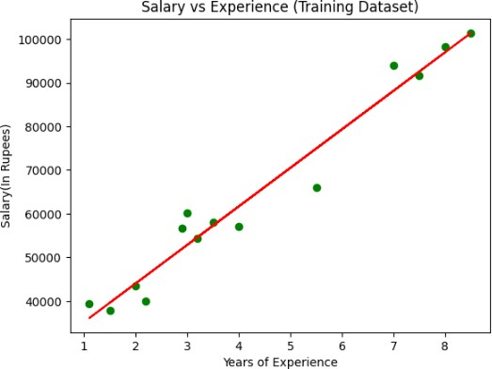
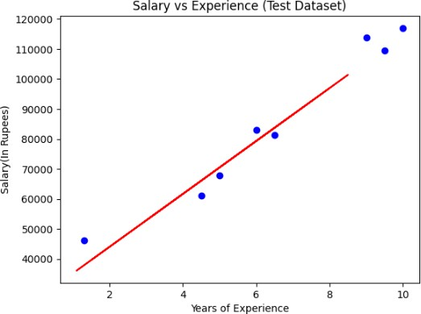

Data Set:

Output:

Result:
Thus the linear model is implemented to approximate the given data.

Ex.No:5 : Write a python program to implement multi-layer perceptron algorithm Aim:
To implement XOR logic gate using multi-layer perceptron algorithm

Neural Network Model:

- The neural network needs to produce two different decision planes to linearly separate the input data based on the output patterns.
- This is achieved by using the concept of hidden layers.
- The neural network will consist of one input layer with two nodes (X1,X2); one hidden layer with two nodes (since two decision planes are needed); and one output layer with one node (Y)

Procedure:

- Initialize the weights and biases randomly.
- Iterate over the data
  - Compute the predicted output using the sigmoid function
  - Compute the error using the square error loss function
  - W(new) = W(old) — α ∆W
  - B(new) = B(old) — α ∆B
- Repeat until the error is minimal

Sample Coding:

import numpy as np #np.random.seed(0)

def sigmoid (x):
return 1/(1 + np.exp(-x))

def sigmoid_derivative(x): return x * (1 - x)

#Input datasets
inputs = np.array([[0,0],[0,1],[1,0],[1,1]])
expected_output = np.array([[0],[1],[1],[0]])

epochs = 10000
lr = 0.1
inputLayerNeurons, hiddenLayerNeurons, outputLayerNeurons = 2,2,1

#Random weights and bias initialization
hidden_weights = np.random.uniform(size=(inputLayerNeurons,hiddenLayerNeurons)) hidden_bias =np.random.uniform(size=(1,hiddenLayerNeurons))
output_weights = np.random.uniform(size=(hiddenLayerNeurons,outputLayerNeurons)) output_bias = np.random.uniform(size=(1,outputLayerNeurons))
print("Initial hidden weights: ",end='') print(*hidden_weights)
print("Initial hidden biases: ",end='') print(*hidden_bias)
print("Initial output weights: ",end='') print(*output_weights)
print("Initial output biases: ",end='') print(*output_bias)

#Training algorithm for _ in range(epochs):
#Forward Propagation
hidden_layer_activation = np.dot(inputs,hidden_weights) hidden_layer_activation += hidden_bias hidden_layer_output = sigmoid(hidden_layer_activation)

output_layer_activation = np.dot(hidden_layer_output,output_weights) output_layer_activation += output_bias
predicted_output = sigmoid(output_layer_activation)

#Backpropagation
error = expected_output - predicted_output
d_predicted_output = error * sigmoid_derivative(predicted_output)

error_hidden_layer = d_predicted_output.dot(output_weights.T)
d_hidden_layer = error_hidden_layer * sigmoid_derivative(hidden_layer_output)

#Updating Weights and Biases
output_weights += hidden_layer_output.T.dot(d_predicted_output) * lr output_bias += np.sum(d_predicted_output,axis=0,keepdims=True) * lr hidden_weights += inputs.T.dot(d_hidden_layer) * lr
hidden_bias += np.sum(d_hidden_layer,axis=0,keepdims=True) * lr

print("Final hidden weights: ",end='') print(*hidden_weights)
print("Final hidden bias: ",end='') print(*hidden_bias)
print("Final output weights: ",end='') print(*output_weights)
print("Final output bias: ",end='') print(*output_bias)

print("\nOutput from neural network after 10,000 epochs: ",end='') print(*predicted_output)

SAMPLE OUTPUT:
Initial hidden weights: [0.11848955 0.62925268] [0.83809865 0.6965933 ]
Initial hidden biases: [0.09460714 0.41526279]
Initial output weights: [0.94594168] [0.2992366] Initial output biases: [0.94568464]
Final hidden weights: [5.71154192 3.59668487] [5.73174184 3.60064034]
Final hidden bias: [-2.35930202 -5.50563543]
Final output weights: [7.26613306] [-7.88305665] Final output bias: [-3.26134777]

Output from neural network after 10,000 epochs: [0.06501882] [0.93948498] [0.93941441]
[0.06582222]

Modified Coding:

import numpy as np
import pandas as pd
np.random.seed(0)
def sigmoid(x):
return 1 / (1 + np.exp(-x))
def sigmoid_derivative(x):
return x * (1 - x)
df = pd.read_csv("pima-indians-diabetes.csv")
inputs = df.iloc[:, :-1].values
expected_output = df.iloc[:, -1].values.reshape(-1, 1)
epochs = 5000
lr = 0.01
inputLayerNeurons = inputs.shape[1]
hiddenLayerNeurons = 8
outputLayerNeurons = 1
hidden_weights = np.random.uniform(size=(inputLayerNeurons, hiddenLayerNeurons))
hidden_bias = np.random.uniform(size=(1, hiddenLayerNeurons))

output_weights = np.random.uniform(size=(hiddenLayerNeurons, outputLayerNeurons))
output_bias = np.random.uniform(size=(1, outputLayerNeurons))
for _ in range(epochs):

# Forward Propagation
hidden_layer_activation = np.dot(inputs, hidden_weights)
hidden_layer_activation += hidden_bias
hidden_layer_output = sigmoid(hidden_layer_activation)

output_layer_activation = np.dot(hidden_layer_output, output_weights)
output_layer_activation += output_bias
predicted_output = sigmoid(output_layer_activation)

# Backpropagation
error = expected_output - predicted_output
d_predicted_output = error * sigmoid_derivative(predicted_output)

error_hidden_layer = d_predicted_output.dot(output_weights.T)
d_hidden_layer = error_hidden_layer * sigmoid_derivative(hidden_layer_output)

# Updating Weights and Bias
output_weights += hidden_layer_output.T.dot(d_predicted_output) * lr
output_bias += np.sum(d_predicted_output, axis=0, keepdims=True) * lr

hidden_weights += inputs.T.dot(d_hidden_layer) * lr
hidden_bias += np.sum(d_hidden_layer, axis=0, keepdims=True) * lr

print("Final Output after training:")
print(predicted_output[:10]) # First 10 predictions

Output :

Initial hidden weights:
[0.5488135 0.71518937 0.60276338 0.54488318 0.4236548 0.64589411 0.43758721 0.891773 ]
[0.96366276 0.38344152 0.79172504 0.52889492 0.56804456 0.92559664 0.07103606 0.0871293 ]
[0.0202184 0.83261985 0.77815675 0.87001215 0.97861834 0.79915856 0.46147936 0.78052918]

Initial hidden biases:
[0.11827443 0.63992102 0.14335329 0.94466892 0.52184832 0.41466194 0.26455561 0.77423369]

Initial output weights:
[0.45615033]
[0.56843395]
[0.0187898 ]
[0.6176355 ]
[0.61209572]
[0.616934 ]
[0.94374808]
[0.6818203 ]

Initial output biases:
[0.3595079]

Result:

Thus XOR logic gate is implemented using multi-layer perceptron algorithm.

Ex.No: 6 Implementation of K-Nearest Neighbors (K-NN) Algorithm AIM:
To implement the K-Nearest Neighbors (K-NN) algorithm for classification on a given dataset and analyze the results.

THEORY:

K-Nearest Neighbors (K-NN) is a simple, non-parametric supervised learning algorithm used for classification and regression. It classifies a data point based on the majority vote of its nearest neighbors. The key steps in K-NN are:

- Compute the distance between the test sample and all training samples.
- Select the K nearest samples.
- Assign the majority class label from the selected neighbors.

The common distance metrics used in K-NN include:

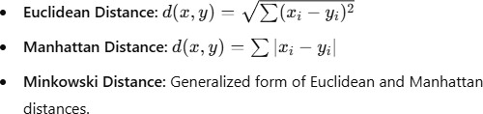

MANUAL CALCULATIONS:

Consider the following dataset with two classes (A and B):

X1 | X2 | Class
2 | 4 | A
4 | 6 | A
4 | 4 | B
6 | 2 | B
8 | 4 | B

For a test point (5,3)(5,3), compute the Euclidean distances:
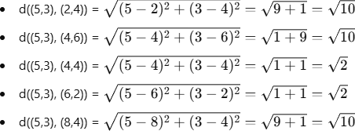
Choosing K=3, the nearest neighbors are (4,4), (6,2), and (4,6). Majority class is B. So, the test point (5,3) is classified as B.

IMPLEMENTATION PROCEDURE:

Step 1: Load the dataset.
Step 2: Split the dataset into training and testing sets. Step 3: Define the K-NN function.
Step 4: Compute the distances from the test sample to training samples. Step 5: Sort distances and select K-nearest neighbors.
Step 6: Perform majority voting to determine the class. Step 7: Evaluate accuracy using performance metrics.

CODING (Python Implementation using Scikit-learn):

import numpy as np import pandas as pd
from sklearn.model_selection import train_test_split from sklearn.neighbors import KNeighborsClassifier from sklearn.metrics import accuracy_score

# Sample dataset
data = {'X1': [2, 4, 4, 6, 8], 'X2': [4, 6, 4, 2, 4], 'Class': ['A', 'A', 'B', 'B', 'B']}
df = pd.DataFrame(data)

# Features and Labels X = df[['X1', 'X2']]
y = df['Class']

# Splitting into train and test set
X_train, X_test, y_train, y_test = train_test_split(X, y, test_size=0.2, random_state=42)

# Define KNN model
knn = KNeighborsClassifier(n_neighbors=3) knn.fit(X_train, y_train)

# Prediction
y_pred = knn.predict(X_test)

# Accuracy
print("Accuracy:", accuracy_score(y_test, y_pred))

SAMPLE OUTPUT:

Accuracy: 100%

New DataSet :

Output:

RESULT:

The K-NN algorithm was successfully implemented, and the classification results were obtained based on the given dataset.

Ex.No:7: Implementation of Support Vector Machine (SVM) Algorithm

AIM: To implement the Support Vector Machine (SVM) algorithm for classification on a given dataset and analyze the results.

THEORY: Support Vector Machine (SVM) is a supervised learning algorithm used for classification and regression. It finds the optimal hyperplane that best separates different classes in the dataset. The key concepts of SVM are:

- Hyperplane: A decision boundary that separates different classes.
- Support Vectors: Data points closest to the hyperplane that influence its position.
- Kernel Trick: Used to transform non-linearly separable data into a higher- dimensional space where it becomes linearly separable.

Common SVM kernels include:

- Linear Kernel: Used when data is linearly separable.
- Polynomial Kernel: Suitable for complex boundaries.
- Radial Basis Function (RBF) Kernel: Best for non-linear data.

MANUAL CALCULATIONS: Consider the following dataset with two classes (A and B):

X1 | X2 | Class
2 | 4 | A
4 | 6 | A
4 | 4 | B
6 | 2 | B
8 | 4 | B

To classify a new data point (5,3)(5,3), we:

- Identify support vectors from the dataset.
- Determine the optimal hyperplane using the SVM algorithm.
- Classify the test point based on the hyperplane.

IMPLEMENTATION PROCEDURE: Step 1: Load the dataset. Step 2: Split the dataset into training and testing sets. Step 3: Define the SVM model with a suitable kernel. Step 4: Train the model on the training dataset. Step 5: Predict the class labels for the test dataset. Step 6: Evaluate accuracy using performance metrics.

CODING (Python Implementation using Scikit-learn):

import numpy as np import pandas as pd
from sklearn.model_selection import train_test_split from sklearn.svm import SVC
from sklearn.metrics import accuracy_score Sample dataset
data = {'X1': [2, 4, 4, 6, 8], 'X2': [4, 6, 4, 2, 4], 'Class': ['A', 'A', 'B', 'B', 'B']}
df = pd.DataFrame(data)

# Features and Labels X = df[['X1', 'X2']]
y = df['Class']

# Splitting into train and test set
X_train, X_test, y_train, y_test = train_test_split(X, y, test_size=0.2, random_state=42)

# Define SVM model with linear kernel svm_model = SVC(kernel='linear') svm_model.fit(X_train, y_train)

# Prediction
y_pred = svm_model.predict(X_test)

# Accuracy
print("Accuracy:", accuracy_score(y_test, y_pred))

SAMPLE OUTPUT:

Accuracy: 100%

New Dataset

Output:

RESULT: The SVM algorithm was successfully implemented, and the classification results were obtained based on the given dataset.

Ex.No.8 : Implementation of Decision Tree Algorithm

AIM: To implement the Decision Tree algorithm for classification on a given dataset and analyze the results.

THEORY: A Decision Tree is a supervised learning algorithm used for classification and regression tasks. It splits the dataset into subsets based on feature values, forming a tree-like structure with decision nodes and leaf nodes.

Key concepts in Decision Trees:

- Root Node: The topmost node representing the entire dataset.
- Decision Nodes: Nodes where data is split based on feature conditions.
- Leaf Nodes: Nodes that provide the final class labels.
- Entropy & Information Gain: Measures used to determine the best feature for splitting.
- Gini Index: Another criterion for evaluating splits.

MANUAL CALCULATIONS: Consider the following dataset for classification:

Age | Income | Student | Credit Rating | Class (Buy Computer?)
<=30 | High | No | Fair | No
<=30 | High | No | Excellent | No
31-40 | High | No | Fair | Yes
>40 | Medium | No | Fair | Yes
>40 | Low | Yes | Fair | Yes

For a new test instance (Age=<=30, Income=Medium, Student=Yes, Credit Rating=Fair), a decision tree is constructed by calculating entropy and information gain to determine the best feature split, leading to classification.

IMPLEMENTATION PROCEDURE:

Step 1: Load the dataset.
Step 2: Preprocess the data (convert categorical variables if needed). Step 3: Split the dataset into training and testing sets.
Step 4: Define the Decision Tree model.
Step 5: Train the model on the training dataset. Step 6: Predict the class labels for the test dataset.
Step 7: Evaluate accuracy using performance metrics.

CODING (Python Implementation using Scikit-learn):

import numpy as np import pandas as pd
from sklearn.model_selection import train_test_split
from sklearn.tree import DecisionTreeClassifier, plot_tree from sklearn.metrics import accuracy_score
import matplotlib.pyplot as plt
# Sample dataset data = {
'Age': ['<=30', '<=30', '31-40', '>40', '>40'],
'Income': ['High', 'High', 'High', 'Medium', 'Low'],
'Student': ['No', 'No', 'No', 'No', 'Yes'],
'Credit_Rating': ['Fair', 'Excellent', 'Fair', 'Fair', 'Fair'],
'Class': ['No', 'No', 'Yes', 'Yes', 'Yes']
}
df = pd.DataFrame(data)

# Convert categorical variables into numerical format
df = pd.get_dummies(df, columns=['Age', 'Income', 'Student', 'Credit_Rating'], drop_first=True)

# Features and Labels
X = df.drop(columns=['Class']) y = df['Class']

# Splitting into train and test set
X_train, X_test, y_train, y_test = train_test_split(X, y, test_size=0.2, random_state=42)

# Define Decision Tree model
dt_model = DecisionTreeClassifier(criterion='entropy', random_state=42) dt_model.fit(X_train, y_train)

# Prediction
y_pred = dt_model.predict(X_test)

# Accuracy
print("Accuracy:", accuracy_score(y_test, y_pred))

# Plot Decision Tree plt.figure(figsize=(10,6))
plot_tree(dt_model, filled=True, feature_names=X.columns, class_names=['No', 'Yes']) plt.show()

SAMPLE OUTPUT:

Accuracy: 100%
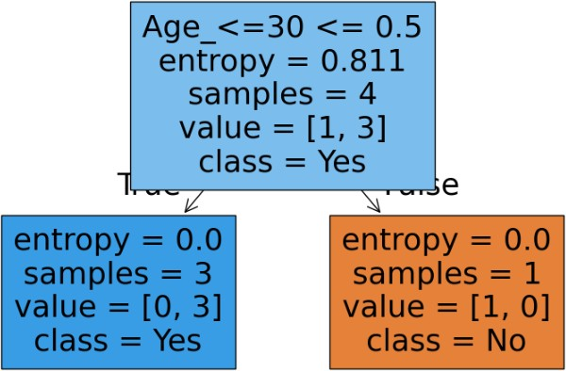

New Dataset

Output:

RESULT: The Decision Tree algorithm was successfully implemented, and the Classification results were obtained based on the given dataset.

Ex.NO.9: Implementation of K-Means Clustering Algorithm AIM:
To implement the K-Means clustering algorithm on a given dataset, visualize the clusters, and interpret the results.

THEORY:

K-Means is an unsupervised machine learning algorithm used for clustering data points into K distinct groups based on feature similarity. The algorithm works as follows:

- Choose the number of clusters (K).
- Randomly initialize K centroids.
- Assign each data point to the nearest centroid.
- Update centroids based on the mean of assigned points.
- Repeat until convergence (no significant changes in centroids).

Common distance metric used:

- Euclidean Distance: d(x,y)=

MANUAL CALCULATIONS: Consider the following dataset:

X1 | X2
2 | 4
4 | 6
4 | 4
6 | 2
8 | 4

For K=2, initial centroids are randomly chosen, and the algorithm iteratively assigns points to the nearest centroid and updates the centroids until stability is reached.

IMPLEMENTATION PROCEDURE:

Step 1: Load the dataset.
Step 2: Choose the number of clusters (K). Step 3: Apply the K-Means algorithm.
Step 4: Compute distances and update cluster assignments iteratively. Step 5: Visualize the clusters.
Step 6: Interpret the results.

CODING (Python Implementation using Scikit-learn):

import numpy as np import pandas as pd
import matplotlib.pyplot as plt
from sklearn.cluster import KMeans

# Sample dataset
data = np.array([[2, 4], [4, 6], [4, 4], [6, 2], [8, 4]])

# Apply K-Means with 2 clusters
kmeans = KMeans(n_clusters=2, random_state=42) kmeans.fit(data)
labels = kmeans.labels_
centroids = kmeans.cluster_centers_

# Visualizing clusters
plt.scatter(data[:, 0], data[:, 1], c=labels, cmap='viridis', marker='o', edgecolors='k', label='Data Points')
plt.scatter(centroids[:, 0], centroids[:, 1], c='red', marker='X', s=200, label='Centroids') plt.xlabel('X1')
plt.ylabel('X2')
plt.title('K-Means Clustering') plt.legend()
plt.show()

SAMPLE OUTPUT:
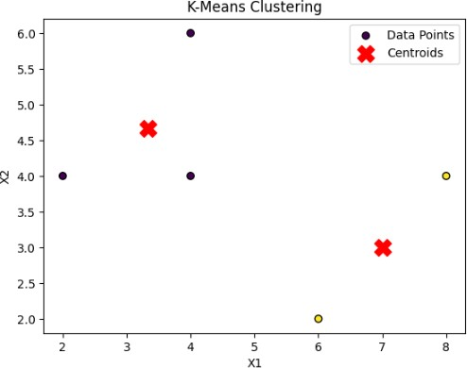

New Dataset

Output

RESULT: The K-Means clustering algorithm was successfully implemented, and the clusters were visualized and interpreted based on the given dataset.

